Scientific Notation  Quiz-Answers | Name_________________________  Date__________________________

Write each number in standard decimal notation without the use of exponents.
- 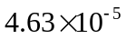 = 0.0000463

- 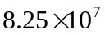 = 82,500,000

Write each number in scientific notation.

- 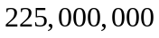 = 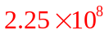

- 0.0000000000125 = 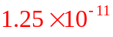

Perform the indicated operations. Write the answer in scientific notation.

-   